SADDLEWORTH MOUNTAIN TIME TRIAL
18TH MAY 2022
J8/7 – 17.6 mile mountain time trial
Promoted for and on behalf of Cycling Time Trials under their Rules and Regulations
Event organiser: Michael Coulter, Manns View, Manchester Road, Greenfield OL3 7HJ
Mobile Number: 07944 663 022

Time Keepers: Martin Jackson & Tony Millington
PRIZES:

(1 rider 1 prize)

1st Male - £100 Rapha Voucher, Large Kwaremont Beer & Glass
2nd Male - £50 Rapha Voucher
3rd Male - £10 Cash

1st Female - £150 Rapha Voucher
2nd Female - £50 Rapha Voucher
3rd Female - £10 Cash

Fastest Vet – Crate of Magic Rock Beers & Glass Fastest Clarion rider – 6 x Cans of Donkeystone Beer
Lanterne Rouge – 6 Boxes of Yorkshire Tea
13th Place – 6 Bags of Coffee & 2 Travel Cups from Dark Woods Coffee

PRIZES WILL BE AWARDED IMMEDIATELY AFTER THE EVENT

EVENT HEADQUARTERS

Donkeystone Brewing Co, Wellington Road Industrial Park, Wellington Road, Greenfield Oldham OL3 7AQ

Headquarters will be open at 17:30.

Riders will need to sign on and collect their numbers from the HQ, where there will be a results board as well as a range of refreshments.

Limited parking is available at the HQ and nearer the Start/Finish line. Do not park at the Start line as this area is required by race officials.

There is some over flow parking on Wellington Road and then on Manchester Road. Please park considerately.

Course Details (J8/7)

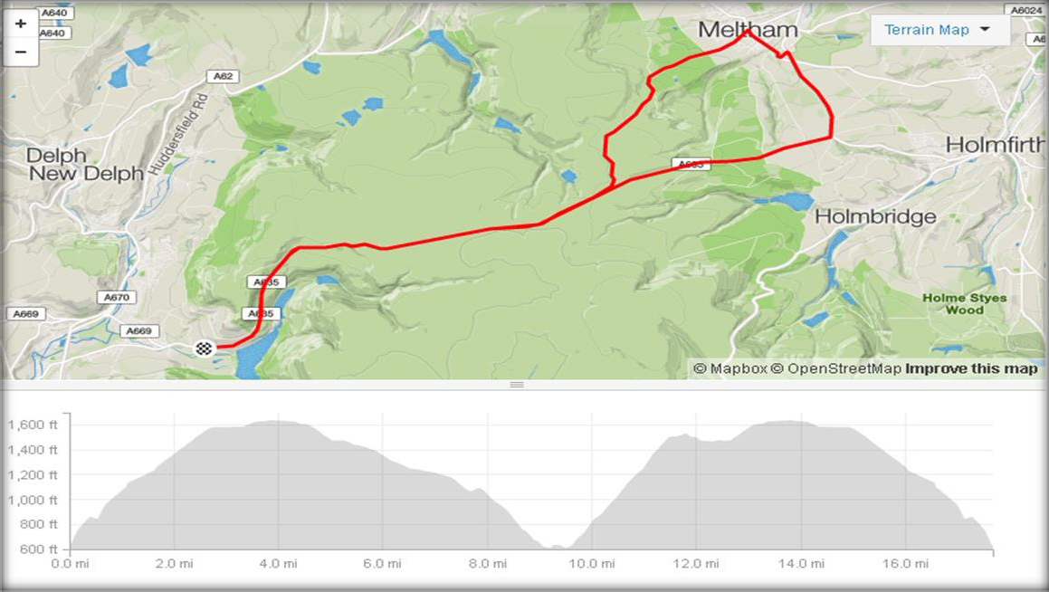The route can be viewed here
https://www.strava.com/routes/4723146
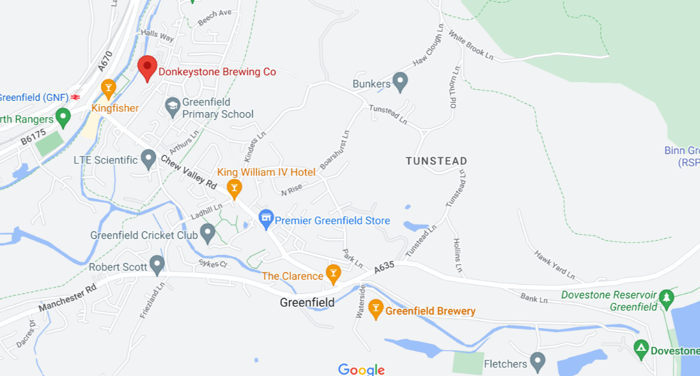
HQ
START/FINISH

- The start is approximately 1.2 miles from the HQ.
- Turn right from HQ onto Wellington Road, at junction with Chew Valley Road turn left. Go straight over the 1st mini roundabout towards The Clarence Hotel.
- Take the first exit and proceed up the hill for approximately 0.5 mile to the layby on the left.
- This is the start line and is opposite the entrance to Dovestones Reservoir.
- Continue up the A365 which flattens out at approximately 4 miles. Please note that on the tops the road surface is uneven.
- Turn left at The Ford Inn at 7.6 miles on to Thick Hollins Road.
- Special care must be taken when descending from The Ford Inn into Meltham.
This rapid descent can experience strong side winds.
- Continue down the hill to the HAIR PIN BENDS at 8.8 miles.
- At 9.5 miles turn left onto Wessenden Head Road and continue up the hill.
- Note – at approximately 11.8 miles there is a cattle grid.
- 12.4 miles TURN RIGHT back onto the A365 and head back towards Greenfield.
PLEASE REMEMBER TO GIVE WAY TO TRAFFIC AT THIS JUNCTION.
- Finish line is at 17.6 miles.
NOTES TO COMPETITORS

No U-turns near the start or finish. Any rider doing so will be disqualified.

This is a Mountain Time Trial, so please ensure bikes are fitted with adequate gearing and brakes. The road surface on the top of the moors is uneven and care must be taken if using tri-bars.
There are several technical descents, which depending on the weather conditions may require care.

The descent in to Meltham on Thick Hollins Road is very fast and can experience unpredictable wind directions. Please take care on this road.

After the ascent of Wessenden Head Road, there is a right turn back on to the A365.

Ride according to road regulations and give way to other traffic before moving onto this road. After completing the course, do not stop at the finish line or disrupt the time keeper.
Due to the nature of the course, there will be a broom wagon driving behind the last rider.

THERE IS A FREE BEER/COFFEE/TEA AND CAKE WHEN YOU RETURN YOUR NUMBER AND SIGN OFF.
IN THE INTEREST OF YOUR OWN SAFETY

All riders must wear a hard shell helmet and have and use operational front and rear lights

This event may be subject to a Doping Control
It is your responsibility to check

As soon as you have finished you should return to the event HQ as it is your responsibility to check if you are required for Doping Control

Race numbers required for Doping Control will be displayed at the HQ adjacent to the result board

If your number is displayed you should report immediately to Doping Control which will be nearby

Remember, it is up to you to check and ensure that you comply

If required you must report to Doping Control after finishing without delay

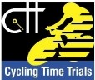
orotecti1otl00rt
UKad

